GUIDELINES FOR MAKING FINAL YEAR PROJECT REPORT
The students of FEST are hereby directed to prepare their final year project 2 reports according to the guidelines provided in the following points.
- The color of front cover binding of the project report should be Navy Blue, for all the students.
- The project report should be hard bound
- The front cover of the report should be in printed form along-with the university logo. The required print spacing on front cover page is as follows:
Top: 1.5 inches Left: 1.5 inches
Right: 1 inch Bottom: 1 inch
Note: For the front cover details contact your project coordinator
- The font used should be Times New Roman, 12 points plain, with one-and-a-half (1.5) spacing between two consecutive lines
- For sub-headings, increase Two point and for main headings increase Two more point.
- The overall number of pages in the report must be a minimum of 60, Excluding the appendix
- All the pages should be properly numbered – preferably section-wise
- The students should get their project reports cross-checked by their advisor before submitting it to the FYPC. Marks will be deduced from the reports not complying the prescribed format.



Project Proposal
for
Project Name
Enhancing Harmful Brain Activity Classification kaggle competition based research initiative
<Submitted by>
Sakina Saifuddin 54573
bisma Zulfiqar 55420
nabeel imtiaz 54857
saad shahid 55280

<Supervisor>
Fahad Najeeb

<Coordinator>

DR. Atiya Masood

Contents
1. List of Abbreviations and Acronyms 2
1. Project Introduction 3
1.1 Aim and Objectives 3
1. Problem Solution for Proposed System 3
2. Related System Analysis/Literature Review 4
2.1.1 Object Detector Mobile Application 4
2.2 Comparison 5
2.4 Summary 5
3 Research Approach 6
3.1 Development / Research Methodology: 6
3.1.1 Development Model: 6
3.2 Justification: 6
3.3 Project Flow: 6
3.4 Key Milestones and Deliverables: 6
3.5 Project Schedule / Milestone Chart: 7
4. Requirement Identifying Technique: 8
4.1 Functional Requirements: 8
4.2 Non - Functional Requirements: 8
4.3 Use Case Diagram: 9
4.4 Use Cases Description: 9
5 Scope: 12
5.2 Prototype: 12
6 Budgeting: 14
6.1 Proposed Budget: 14
7 Business Canvas: 15
7.1 Business Canvas 15

List of Abbreviations and Acronyms

- AI: Artificial Intelligence.
- EEG: Electroencephalography or Electroencephalogram.
- ML: Machine Learning.
- CNN: Convolutional Neural Network.
- HMS: Harvard Medical School
- ANN: Artificial Neural Network.
- RF: Random Forests.
- PD: Parkinson's disease.
- ND: Neurodegenerative disease.
- HCs: Healthy controls.
- MCI: Mild Cognitive Impairment.
- WT: Wavelet Transform.
- FFT: Fast Fourier Transform.
- AD: Alzheimer's disease.
- BCI: Brain-computer interface.
- KNN: k-Nearest Neighbors.
- SVM: Support Vector Machine.
- DL: Deep learning.

Project Introduction
Introduction: Specify the purpose of this project proposal document along with a description detailed background
Background:
Electroencephalography (EEG), which provides a non-invasive window into the brain's electrical activity, has long been a mainstay of neuroscientific study and clinical diagnosis. Applications for it include cognitive function-based device control interfaces and clinical diagnostics for illnesses such as epilepsy. Even with their extensive application, the task of improving the precision and instantaneous functioning of EEG-based systems for brain state categorization and anomaly identification persists.
Current neurocritical care and epilepsy treatment mainly rely on absolutely correct and timely interpretation of electroencephalography (EEG) signals to detect seizures and other abnormal activities in the brain. Nevertheless, the manual analysis of EEG signals by specialized neurologists consumes much time, is prone to human error, and may lead to fatigue, which in turn questions the reliability of the interpretations. Considering this, the need for an automated, reliable, and efficient system capable of analyzing EEG data arises in order to assist in rapid and accurate diagnosis and treatment planning. Advancements in research and practical applications have demonstrated promising outcomes in improving the interpretation of EEG data through the use of machine learning algorithms. The most effective application of these technologies in real-time clinical settings and the precision with which these systems can recognize particular brain states or anticipate occurrences like seizures, however, remain unmet. This is where our project comes into the picture.

Our project aims to create a machine learning (ML) model capable of detecting and classifying seizures and six specific patterns of harmful brain activity: seizure, generalized periodic discharges (GPD), lateralized periodic discharges (LPD), lateralized rhythmic delta activity (LRDA), and generalized rhythmic delta activity (GRDA). This model will utilize EEG (electroencephalogram) data from critically ill hospital patients, reducing the need for manual interpretation which can be inconsistent and prone to errors, especially when neurologists are fatigued. The main focus of our project is to obtain and utilize a relevant EEG dataset from Kaggle, which includes EEG recordings with annotations that mark the presence of these different brain activity patterns. This approach is an example of supervised learning, where the dataset is already labeled, allowing us to train our model on known data to recognize and predict similar patterns in new EEG recordings accurately.
Motivation and Need: (Please describe the motivation and need for this work. Maximum 500 words.)
Around 3 billion people globally are affected by neurological disorders, enduring prolonged and complex diagnostic processes that can extend up to two years to confirm a diagnosis. This delay burdens patients with uncertainty and discomfort and significantly strains healthcare resources. The need for a more efficient diagnostic approach is evident and forms the core motivation of our final-year project.
Our initiative seeks to harness advanced imaging techniques to analyze brain activity more swiftly and accurately. We employ spectrogram images derived from EEG data, tests that monitor the electrical activity in the brain. These images enable us to quickly recognize patterns that may indicate a neurological disorder, substantially shortening the diagnostic timeline.
The primary significance of our project lies in its potential to reduce misdiagnoses, which often lead patients down inappropriate treatment paths, compounding their suffering and delaying necessary medical intervention. By enhancing the precision of initial diagnoses, our project aims to alleviate patient distress and streamline the treatment process.
Moreover, this project offers critical support to neuro-specialists, particularly in regions suffering from a shortage of qualified professionals. By optimizing the diagnostic process, we can extend the reach of existing specialists, allowing them to manage a higher volume of cases without sacrificing the quality of care. This is particularly crucial in rural or underserved areas, where access to specialized neurological care is often limited.
In conclusion, our goal for this project was to develop a CNN model that can assist neuro-specialists in helping them categorize spectrograms. By improving diagnostic procedures, we aim to enhance patient outcomes, reduce the economic impact on healthcare systems, and increase the accessibility of specialized care. This endeavor addresses a significant global health challenge and contributes to the broader goal of more efficient medical service delivery.

Aim and Objectives
(Please describe the measurable objectives of the project and define the expected results. Use results-oriented wording with verbs such as ‘to develop.’, ‘to implement..’, ‘to research..’, ‘to determine..‘, ‘to identify..’ The objectives should not be statements and should actually specify in simple words what the project team intends to achieve (something concrete and measurable/ deliverable).

Objectives:
- To develop a Convolutional Neural Network (CNN) model capable of classifying spectrogram images from EEG data to identify various patterns of brain activity, including seizures and other harmful neurological phenomena.
- To implement an algorithm that predicts the distribution of medical opinions on EEG readings, thus providing a probabilistic diagnosis that reflects the true uncertainty present in expert assessments.
- To research and apply advanced image processing techniques to enhance the accuracy of spectrogram analysis, aiming to differentiate between normal and abnormal brain activities effectively.

- To determine the best machine learning model by comparing the performance of various architectures including basic CNNs and advanced models like EfficientNetB0, using the Kullback-Leibler divergence as the evaluation metric.
- To identify and quantify the improvements in diagnostic speed and accuracy through the use of automated analysis in comparison to traditional methods, thereby aiming to reduce the diagnostic timeline for patients with neurological disorders.

Problem Solution for Proposed System
Expected Outcomes: (Provide a list of proposed project outputs including publications, databases etc.)
The expected outcomes will collectively contribute to the project's goal of improving the diagnostic process for neurological disorders, making it faster, more accurate, and accessible for medical professional, which are as follows:

- A robust ML model that can detect and classify EEG patterns, particularly for seizures and other significant neurological conditions.
- An algorithm that reduces the manual workload on neurologists by providing automatic EEG analysis and consistent diagnostic interpretations.
- Expected to increase the accuracy of diagnosing neurological disorders by improving the alignment of model predictions with actual expert opinions using the KL divergence metric.

- Significantly decrease the time required to diagnose neurological conditions by automating the analysis of EEG spectrogram images.

- The project will deliver quantitative metrics such as KL divergence values to assess the model's prediction effectiveness.

- Identify the most effective CNN architecture for neurological disorder analysis.

- A user-friendly diagnostic tool will be developed, integrating the model to assist medical professionals in efficiently interpreting EEG data.

Technology Transfer/Diffusion Approach: (Please describe how the outputs of the project will be transferred to the beneficiaries/customers. Maximum 500 words.)
For example: A mobile application will be starting point, it will access to camera and use image frames to identify the object with ML algorithms and keep matching with images in DB. Simple calculation will be used to calculate the distance of an object. Based on the distance calculation, algorithm will be used to command the person to change the direction in order to avoid collision with object. GPS will be used to keep tracking of that person. Storage access will be required if the given dataset will be huge. This process will keep going on until the blind person reaches destination.

The diagnostic process of a neurological disorder begins with the detailed collection of EEG data. The EEG test meticulously records the brain's electrical activity, producing detailed spectrogram images ready for immediate analysis.
Upon collection, the EEG data is promptly processed by the model. This model utilizes a specialized metric, the Kullback-Leibler divergence, which is highly effective for analyzing complex data sets. The model examines the spectrogram images through this analysis to identify specific brain activity patterns that indicate various neurological conditions. This thorough analysis converts raw data into a detailed, probabilistic diagnosis, providing quantified likelihoods of different disorders based on the observed data. This approach enhances the diagnostic process by offering identifications and nuanced probabilities of various conditions, thus providing precision and depth to the diagnostics.
The results from this analysis are displayed almost immediately on the monitors connected to the EEG equipment, providing doctors and neurologists with timely and essential diagnostic information. They receive a clear breakdown of probability scores for different neurological conditions, presented in a format that is easy to understand. This quick access to detailed diagnostic information significantly streamlines the clinical decision-making process, reducing the need for lengthy consultations or the necessity for second opinions and enabling medical professionals to quickly and accurately understand the patient's neurological status.
With the accurate diagnostic information provided by the model, neurologists are equipped to make informed decisions about the next steps in the patient's care. The reliability of the model's predictions is crucial; it underpins clinical decisions about the patient’s treatment plan. Depending on the patient's specific condition, this might include prescribing medications, planning surgical interventions, or arranging further diagnostic tests. Each decision is informed by the detailed insights from the model, ensuring treatments are precisely tailored to meet the patient's individual needs and significantly reducing the risks associated with potential misdiagnosis.
In summary, this enhanced diagnostic capability ensures that patients receive the most appropriate and timely medical interventions. By utilizing an advanced model coupled with the analytical precision of a specialized metric, our approach elevates the standard diagnostic practices, offering a more dynamic, responsive, and patient-centered approach to neurological care. This improves patient outcomes and positions the healthcare facility at the forefront of neurological diagnostics, setting new benchmarks for the accuracy and efficiency of patient care in the neurology field.

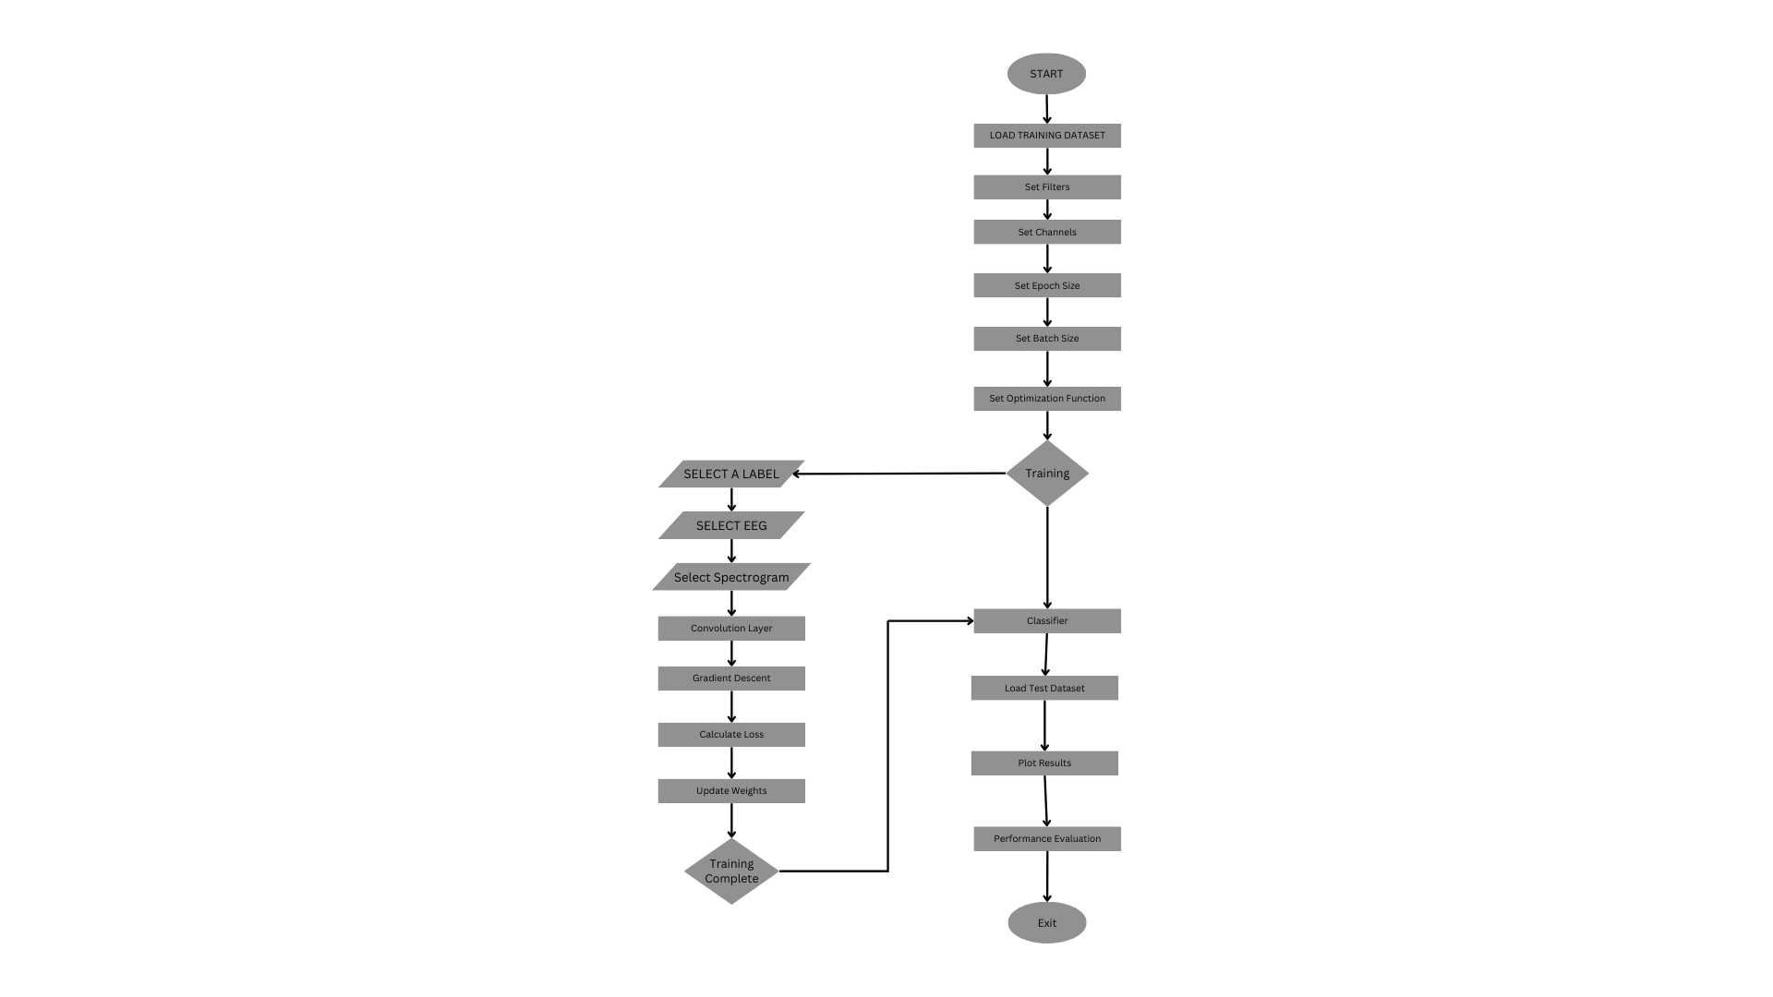

FIG: 1.1
This flowchart represents the iterative process of training and refining a CNN model specifically for EEG data analysis, emphasizing the use of the Kullback-Leibler divergence metric to ensure the model's outputs are statistically aligned with expected outcomes.

Related System Analysis/Literature Review

Write about the existing/similar systems related to your proposed project. At least five existing systems should be discussed. Briefly explain the related system analysis which help to specify the contribution of the proposed project. (Note: Research based projects may provide literature review instead of related system analysis.)

Related System Analysis/Literature Review

(Detailed summary of what all has been done internationally in the proposed area quoting references and bibliography. Maximum 1500 words.)
- Literature Review

Electroencephalography (EEG), which provides a noninvasive window into the brain's electrical activity, has long been a mainstay of neuroscientific study and clinical diagnosis. Applications for it include cognitive function-based device control interfaces and clinical diagnostics for illnesses such as epilepsy [1]. The task of improving the precision and instantaneous functioning of EEG-based systems for brain state categorization and anomaly identification persists, even with their extensive application.
Advancements in research and practical applications have demonstrated promising outcomes in improving the interpretation of EEG data through the use of machine learning algorithms. The most effective application of these technologies in real-time clinical settings and the precision with which these systems can recognize particular brain states or anticipate occurrences like seizures, however, remain unmet. This is what our project focuses on.
This literature review aims to investigate the state of machine learning applications in the interpretation of EEG data, with a particular focus on the effectiveness of different algorithms in categorizing different types of brain activity. This review will evaluate the effectiveness and applicability of algorithms like Random Forest, Support Vector Machines, and Neural Networks by looking at research that has used them. The goal is to identify advancements that could close current gaps in the area.
In the pursuit of enhancing the classification of harmful brain activities, considerable international research has been devoted to developing and refining machine learning (ML) and deep learning (DL) methodologies. These efforts have been significantly represented in various high-impact publications and across several competitive platforms like Kaggle.

  - Previous Analysis Of Machine Learning Algorithms On EEG Data For Brain State Intelligence
A thorough assessment of the efficacy of different algorithms in categorizing brain states is given by Chan et al. (2015) [2] in their investigation of EEG data processing through machine learning approaches. This study is important because it tests machine learning techniques such as Random Forest, Boosting, Naïve Bayesian Classifier, k-Nearest Neighbors (KNN), and Support Vector Machine (SVM) in a systematic manner on various EEG data set configurations. When trained and tested on three data sets from the same subject, Random Forest regularly beats competing algorithms with up to 84% accuracy. Other algorithms, like SVM, on the other hand, performed far less well, averaging about 50% accuracy, which is just a little bit over the level of random guessing.[3] This notable performance disparity is highlighted.

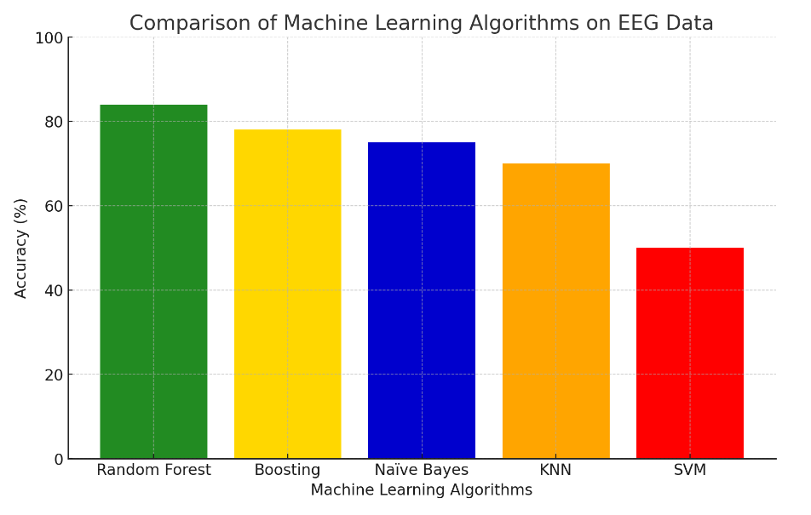
FIG: 2.2

Out of all the algorithms, the highest accuracy level reached by Random Forest was 84%, which occurs in the cases where a model was trained using three data sets from the same subject and then tested against data sets from the same subject. [5] The results from these tests of the Boosting method were the second most accurate, after Random Forest. Random Forest has the best accuracy, exceeding SVM, which is about as accurate as random guessing. When used in a literature study, this graphic can effectively illustrate how different algorithms perform and emphasize how Random Forest is a good fit for jobs involving the processing of EEG data. ​

3.1 Enhancing Harmful Brain Activity Classification: A Review of Global Research Efforts

The deployment of DL algorithms has been noted to offer substantial improvements in classification tasks. For example, Convolutional Neural Networks (CNNs) have been adapted for P300 spellers in the EEG-based brain-computer interface (BCI) applications, showing promise in reducing the number of repetitions needed for correct classification, hence decreasing both typing error and cognitive load on the users (Borgomaneri et al., 2020) [6].

Innovative approaches to feature extraction and classification have been particularly impactful in seizure detection. Advanced algorithms such as AdaBoost and Decision Trees have shown effectiveness, especially when combined with time-frequency analysis techniques, in distinguishing between seizure and non-seizure states with high accuracy (Delimayanti et al., 2019; Hassan and Bhuiyan, 2019) [7].

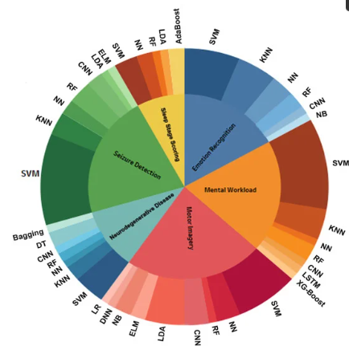
Fig 3.1 illustrates the most efficient machine learning algorithms for different tasks, showing the frequency of their usage across various studies, with CNN, SVM, and RF being the most prevalent.

4.1 Simplified Overview of EEG Data Analysis for Brain Activity Classification

Various research studies have applied different EEG feature extraction methods and machine learning classifiers to improve diagnostic accuracy in the realm of enhancing brain activity classification, especially focusing on Alzheimer's disease (AD). Spectral entropy, Fast Fourier Transform (FFT), and Wavelet Transform (WT) have been predominantly utilized to differentiate AD patients from healthy controls (HCs) and those with Mild Cognitive Impairment (MCI).

A significant contribution to this field was the combination of spectral entropy and SVM classifiers, which provided a remarkable accuracy of 96%, indicating a superior performance over KNN classifiers in distinguishing AD from other cognitive states (Kulkarni et al., 2020) [8].

In neurodegenerative disease (ND)- related studies focusing on Parkinson's disease (PD), Morabito et al. (2019) [9] have applied FFT and KNN classifiers to differentiate PD patients from HCs with an accuracy of 88%, showcasing the effectiveness of combining traditional and machine learning approaches for diagnostic enhancements.

Summary:

This gives an overview of an advanced system capable of classifying harmful brain activity by incorporating useful machine learning and deep learning techniques/algorithms. This system will automate the analysis of EEG patterns and integrate seamlessly with existing healthcare technologies, providing neurologists and medical professionals with real-time diagnostic solutions. The overarching goal of this automated analysis is to enhance the accuracy and reduce human error in EEG interpretation, thereby improving patient outcomes and streamlining the clinical workflow. This is achieved through the strategic application of algorithms such as Support Vector Machines (SVM), Random Forests, and Neural Networks, all under the umbrella of machine learning methods to ensure robustness and reliability in performance. Future research may benefit from a more integrated approach that combines these powerful technologies to explore their full potential in real-world applications.

  - Key Benefits and Beneficiaries:
(Please identify clearly the benefits and potential customers/beneficiaries of the project.)
For example
- Key Benefit: It will help blind person to move within a building.
- Beneficiaries: All blind people.

Key Benefit: The primary benefit of our EEG analysis optimization project is the enhanced accuracy in diagnosing neurological disorders. Neurologists can quickly and accurately interpret EEG data by integrating an optimized Convolutional Neural Network (CNN) into a user-friendly mobile application, leading to faster and more precise diagnoses. This improvement in diagnostic capabilities can significantly reduce the time to treatment, potentially improving patient outcomes in critical neurological conditions.

Beneficiaries: This project's direct beneficiaries are neurologists and healthcare providers who specialize in neurology. These medical professionals will utilize the application to improve their diagnostic processes, particularly for conditions like epilepsy and other disorders that require detailed EEG analysis. Additionally, the secondary beneficiaries include patients suffering from neurological disorders who will benefit from quicker and more accurate diagnoses and tailored treatment plans.

Summary
The analysis of current EEG interpretation systems reveals certain inefficiencies, particularly in the manual and subjective nature of traditional EEG data analysis, which can lead to inconsistent and inaccurate diagnoses of neurological disorders. Our project addresses these issues by by training Convolutional Neural Network (CNN) model for EEG data interpretation, aiming to enhance both the accuracy and speed of diagnoses.

The project significantly simplifies and improves the diagnostic process by eliminating the complexities and inconsistencies associated with traditional EEG interpretation methods. The mobile application's intuitive interface and robust backend ensure that it seamlessly integrates into existing medical workflows, providing neurologists with a reliable tool for making quick and informed decisions. This benefits healthcare providers by enhancing diagnostic capabilities and greatly improves patient outcomes by facilitating faster and more accurate treatment interventions for neurological conditions.

Research Approach

Key Milestones and Deliverables:
(Please list and describe the principal milestones and associated deliverables of the project. The timing of milestones is also to be shown in the Gantt chart in Annexure-A. Quarterly deliverables are preferred.)
S. No. | Elapsed time since start of the project | Milestone | Deliverable
1. | Week 01 – 04 | Project initiation and research, submission of group information form | Group information form, project kick-off meeting and project analysis
2. | Week 05 | Meeting log, submission of activity form, understanding the new outline as the per GA’s | Weekly meeting log, activity form submission, technical details of project development and research plan, system design and architecture specification, timeline, milestones and Gantt chart
3. | Week 06 | Meeting log, submission of activity form, understanding the outline as per CLO’s and PLO’s | Weekly meeting log, activity form submission, technical details of project development and research plan, system design and architecture specification, timeline, milestones and Gantt chart.
4. | Week 07 | Meeting log, activity form submission, project development and research methodology, challenges, aims and objectives identified | Weekly meeting log, activity form, requirements documentation, system architecture design, system design and technology specifications, project schedule and work breakdown structure
5. | Week 08 | Meeting log and activity form submission according to “Chapter 02: Background Information and Literature Survey” | Weekly meeting log, activity form submission, relevant background information, aims and details entailing importance of project
6. | Week 09 | Meeting log and submission of activity form according to Chapter 03 | Weekly logs and activity form submission including use cases, ERD and prototyping
7. | Week 10 | Meeting log, activity form submission and project report initiation | Weekly meeting log, activity form, report checking through supervisor, progress evaluation, updated excel marks sheet
8. | Week 11 | Meeting log, activity form submission and continuation of report work | Weekly meeting log, activity form, report checking through supervisor, progress evaluation, updated excel marks sheet
9. | Week 12 | Meeting log, submission of activity form and budget proposal | Meeting log, activity form submission, weekly report checking through supervisor, resource allocation plan
10. | Week 13 | Meeting log, activity form, and Business Model Canvas submission | Weekly meeting log, activity form submission, customer segments, value proposition, revenue streams, channels, customer relationships, key activities, key resources, key partners and cost structure
11 | Week 14 | Meeting log, submission of activity form and project poster, and progress tracking of final project report | Weekly meeting log, submission of project activity form and poster, weekly report checking through supervisor
12 | Week 15 | Project closure: Submission of final project report and presentation | Final project report submission and student progress tracking, lessons learned documentation, project evaluation and feedback, presentation, closure meeting with supervisors

Project Schedule / Milestone Chart:
(Project schedule using MS-Project (or similar tools) with all tasks, deliverables, milestones, cost estimates, payment schedules clearly indicated are preferred.) Also identify the dependencies (which tasks cannot be started/completed,until the dependent task is completed).
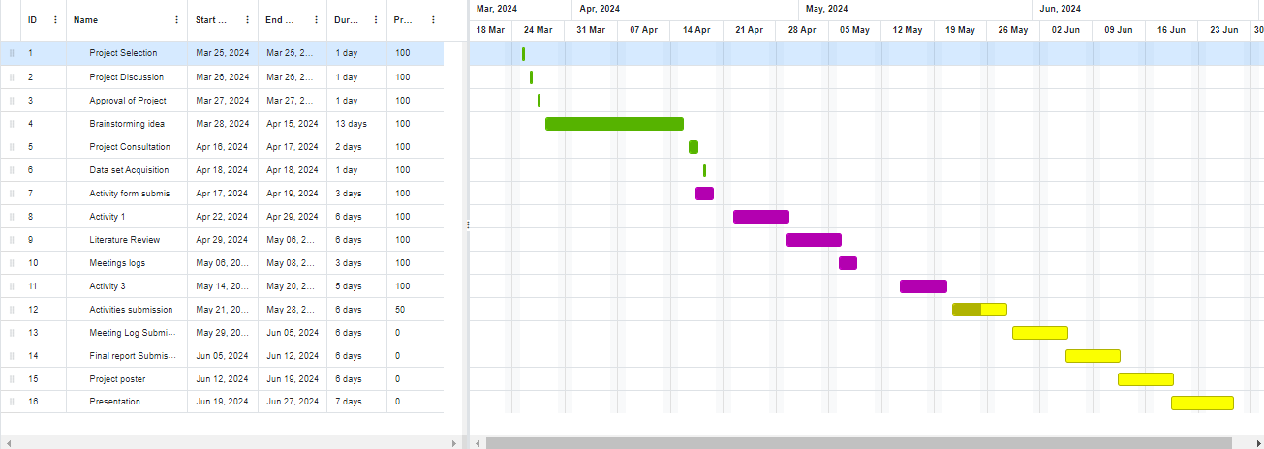

4. Requirement Identifying Technique:

- Data Set
The dataset we are using was compiled by Harvard Medical School (HMS). For this dataset, expert annotators reviewed 50-second-long EEG samples plus matched spectrograms covering a 10-minute window centered at the same time and labeled the central 10 seconds. It contains images of EEG signals, Spectrograms of every EEG signal, and Metadata for both. Our images are distributed into two sets: one for training and the other for testing.
- train_eegs: Images of EEG Data from one or more overlapping samples. All of the samples were collected at a frequency of 200 samples per second.
- train_spectrograms: Spectrograms assembled EEG data.
- test_eegs: Exactly 50 seconds of EEG data.
- test_spectograms: Spectrograms assembled using exactly 10 minutes of EEG data.

The dataset available on Kaggle’s website is in the .csv file.
train.csv: Metadata file of our dataset. This file allows us to extract the original subsets that the raters annotated. However, it contains:
- eeg_id - A unique identifier for the entire EEG recording.
- eeg_sub_id - An ID for the specific 50 second long subsample this row's labels apply to.
- eeg_label_offset_seconds - The time between the beginning of the consolidated EEG and this subsample.
- spectrogram_id - A unique identifier for the entire EEG recording.
- spectrogram_sub_id - An ID for the specific 10 minute subsample this row's labels apply to.
- spectogram_label_offset_seconds - The time between the beginning of the consolidated spectrogram and this subsample.
- label_id - An ID for this set of labels.
- patient_id - An ID for the patient who donated the data.
- expert_consensus - The consensus annotator label. Provided for convenience only.

- Algorithms parameter settings
Pretrained Classifier: EfficientNetV2
EfficientNetV2 is a sophisticated pre-trained model for image-based data classification. We are using the “S” architecture of this model, which has 6 convolutional blocks. Each convolutional block has 2 layers:
- Convolution Layer: This model uses a single convolution layer. The number of filters in the layer is 1408, i.e., our model will work on extracting 1408 features from the image. The batch size and image dimensions are not set as they will vary.
- Pooling Layer: This model uses a single Average pooling layer. Because max pooling and min pooling eliminate certain pixel areas, we utilized a model that would use average pooling, as it selects the average pixel value, which was significant in our classification as the spectrogram has both high and low pixel values.

Optimization Algorithm: ADAM
Instead of using classical stochastic gradient descent, we are using ADAM optimization algorithm as:
- It is computationally efficient.
- It has low memory requirements.
- Well suited for problems that are large in terms of data and/or parameters.
- Appropriate for problems with very noisy and/or sparse gradients.
ADAM algorithm maintains a pre-parameter learning rate that improves performance on problems with sparse gradients. These learning rates are also adaptable in ADAM algorithm based on the average of recent magnitudes of the gradients for the weights.

LOSS Function: KL Divergence
Even though it's our performance metric, KL Divergence is also differentiable, so we can use it as our Loss Function as well. EfficientNetV2, trained with this loss function, will effectively capture complex patterns in the EEG spectrograms, leading to accurate classification of brain disease patterns.

Epochs: 30
Epoch is the number of times our Model will go through a complete dataset for training. Therefore, we will be using around 30 epochs. However, this number could vary between 25 and 35.

- Termination Condition
Our termination condition is based on a fixed number of epochs. There is no early stopping or time-based stopping. We will make our model pass through the complete dataset in a fixed amount of time.

- Performance Measure
Using KL divergence as the loss function for our brain disease classification is suitable because it measures the divergence between the predicted probability distribution and the true distribution of EEG patterns (SZ, GPD, LPD, LRDA, GRDA, and other). This is crucial for our multi-class classification task, as it ensures the model learns to output probabilities that closely match the experts' annotations.
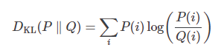

Use Case Diagram

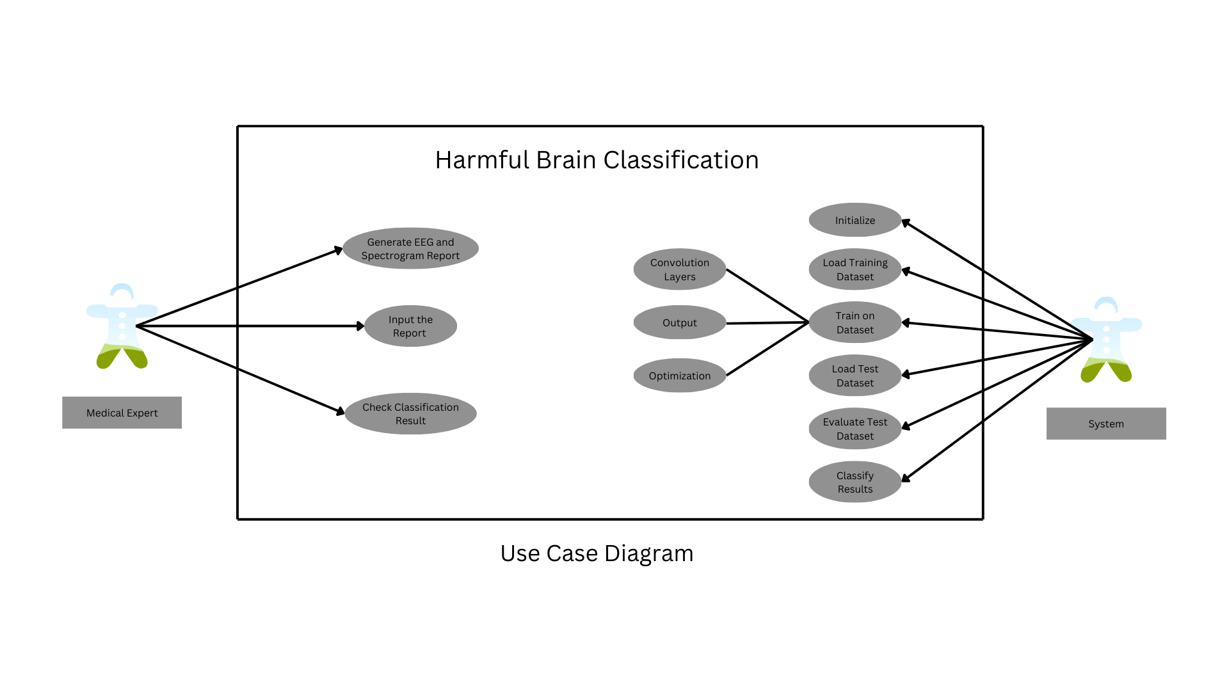

Fig 4.1: There are 2 actors in our scenario. The system will train on the dataset using Convolutional neural network architecture. It will optimize itself by evaluating its output. Finally, when our model is trained, it will pass through the test dataset and classify the result which we can evaluate. Our other actor is a medical expert who will generate EEG reports and spectrograms, and once they do it, they will pass this image to our model, which will then classify the disease.

High Level Architecture of HMS - Harmful Brain Activity Classification

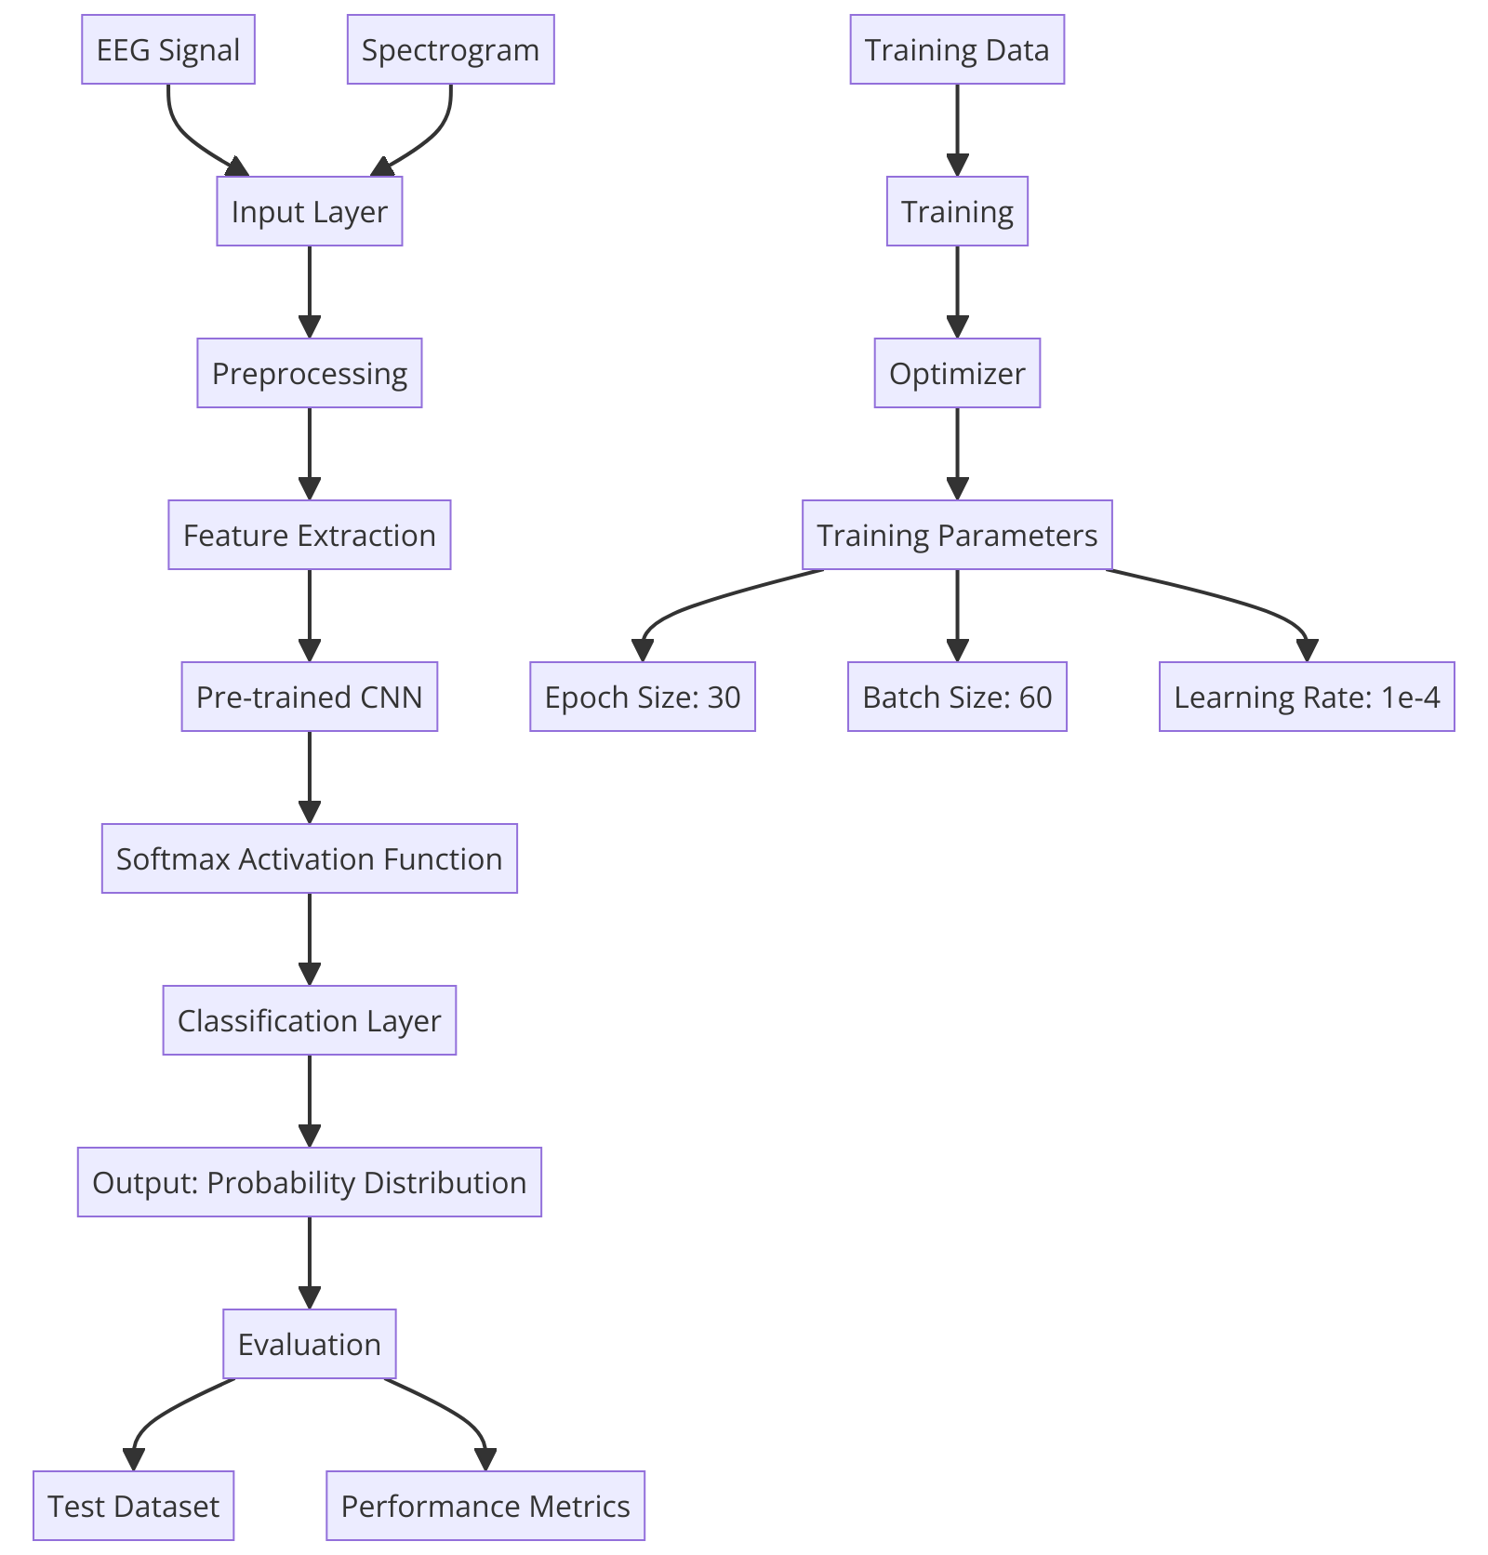

Fig 5.1
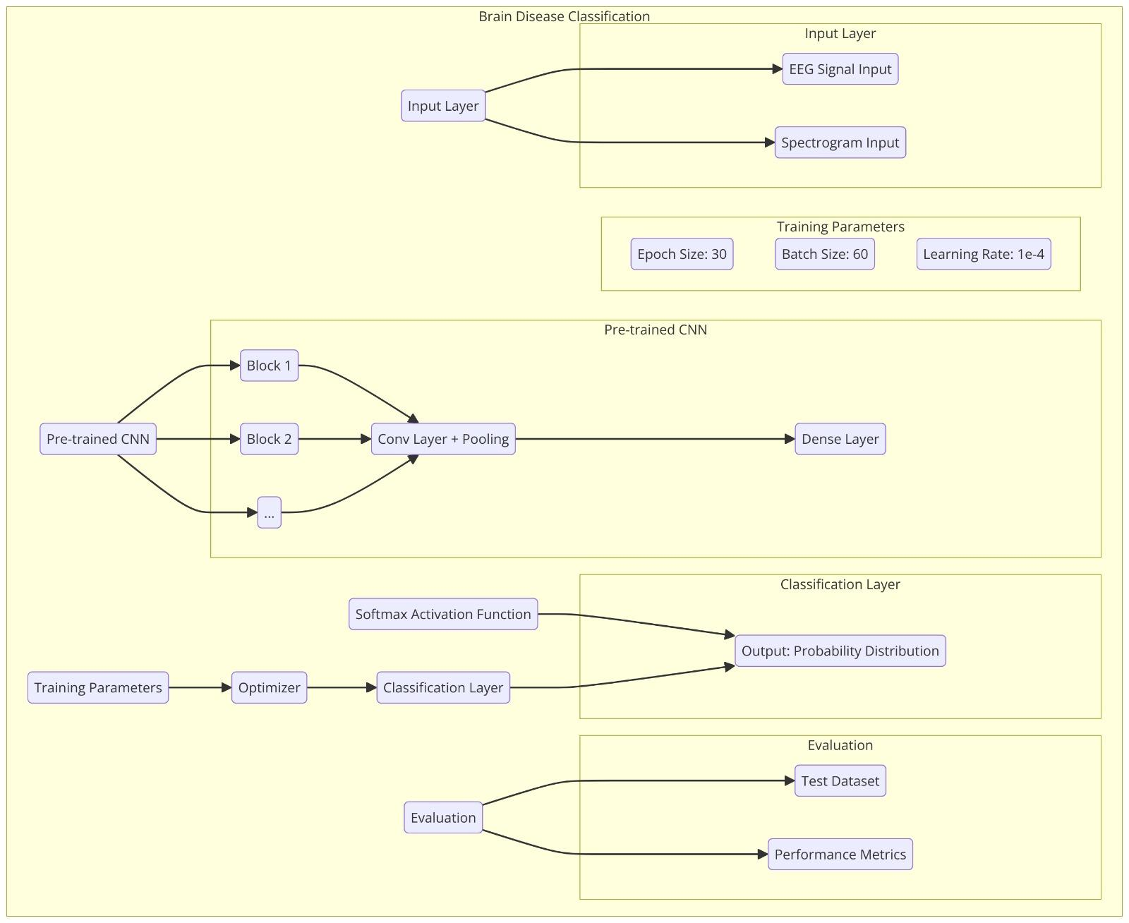
Fig 6.1

1.Input Layer:

EEG Signal Input: This layer is responsible for receiving the raw EEG signals. These signals are typically time-series data representing electrical activity in the brain.
Spectrogram Input: Spectrograms are graphical representations of the EEG signals, showing how the signal's frequency content varies over time. This input is crucial for capturing the temporal and spectral characteristics of the EEG data.

- Pre-trained CNN (EfficientNetV2_B2_imagenet):

Input Processing: This step involves normalizing the spectrogram images to ensure they fit the pre-trained model's expected input format. It handles varying image dimensions and batch sizes, making the model flexible and robust.
Convolutional Blocks: EfficientNetV2_B2 consists of 6 convolutional blocks, each designed to extract increasingly complex features from the input images. Each block includes:
Convolutional Layer: Applies multiple filters (1408 in this case) to the input data, detecting edges, textures, patterns, and other features.
Average Pooling Layer: Reduces the size of the feature maps while preserving important information, making the computation more efficient and reducing overfitting.

- Dense Layer:
This fully connected layer connects all neurons from the previous layer to each of the 6 output nodes, corresponding to the six disease categories. This layer is critical for combining the extracted features and making the final classification.

- SoftMax Activation Function:

The softmax function transforms the outputs from the dense layer into a probability distribution. Each output node's value is between 0 and 1, and the sum of all outputs is 1. This allows the model to output a probabilistic classification, indicating the confidence level for each category.

- Classification Layer:

The classification layer interprets the softmax output, identifying the most likely disease category based on the highest probability. This final output provides the diagnosis.

- Optimizer ADAM Algorithm:
The ADAM optimizer is used to update the model's weights during training. It combines the advantages of two other popular optimization algorithms: AdaGrad and RMSProp, providing efficient and reliable training performance.

- Training Parameters:

Epoch Size: 30 epochs mean the entire training dataset is passed through the model 30 times. This is generally sufficient for the model to learn the patterns in the data.
Batch Size: A batch size of 60 indicates that the model processes 60 samples at a time before updating the weights. This helps in efficient memory utilization and faster training.
Termination Function: Training is terminated after a fixed number of epochs (30 in this case), ensuring the model does not overfit the training data.

- Evaluation:

After training, the model's performance is evaluated using a separate test dataset. The predicted categories are compared to the true labels to assess the accuracy, precision, recall, and other performance metrics.

This high-level architecture ensures that the model can efficiently process and classify EEG signals into the six specified categories, providing a robust tool for harmful brain activity.

Scope:

Limitations of the Project

1. Our project's success heavily relies on the quality and comprehensiveness of the EEG data obtained from Kaggle. Limitations in data variety, volume, or annotations could restrict the model's learning capacity and its generalization to real-world scenarios.

2. While we aim to optimize a Convolutional Neural Network (CNN) for EEG data analysis, the specific architecture chosen (EfficientNetV2) may not capture all nuances of EEG signals compared to potentially more suitable but unexplored algorithms.

3. Given the complexity of neural networks and the volume of data processed, our project might face limitations related to computational resources, such as processing power and memory, which could affect the model's training efficiency and scalability.

4. Although our model is designed for high accuracy, transitioning from a controlled experimental setup to a real-time clinical application might introduce performance discrepancies due to varying operational conditions and hardware limitations.

5. Our model focuses primarily on seizure detection and might not perform with the same accuracy when dealing with other neurological conditions unless specifically trained to do so.

6. Despite aiming to reduce the reliance on manual EEG analysis, completely eliminating expert oversight is unfeasible. Neurologists' expertise will still be crucial for validating and interpreting the model's outputs, especially in complex cases.

Exclusions from the scope:

1. The project will not handle data types other than EEG, such as MRI or CT scans.

- While the model is primarily focused on seizure detection, it will not cover all neurological conditions unless further specified and trained for such.

- The initial deployment will target specific clinical settings, and full integration across all existing hospital systems is not covered.

4. The project is software-centric; it does not include the development of EEG hardware or modification of existing EEG apparatus.

5.3 Team Members Individual Tasks/Work Division (Please define role/key responsibilities of each member. If in collaboration with another partner, the division of manpower at various locations of partners be provided.)
Student Name | Key Responsibilities
Sakina Saifuddin | Manages the overall project documentation, compiles sections from team members, and ensures consistency and completeness.
Nabeel Imtiaz | Learn Python algorithms and also know how to implement them and modify algorithms. Research and document machine learning algorithms, specifically focusing on Convolutional Neural Networks (CNNs) and their application in our EEG System.
Bisma Zulfiqar | Responsible for creating all kinds of diagrams include within the project. Helps in compilation and research work.
Saad Shahid | Responsible for documenting the app’s use cases, additional research information, and designing the UI prototype interface.

Budgeting:
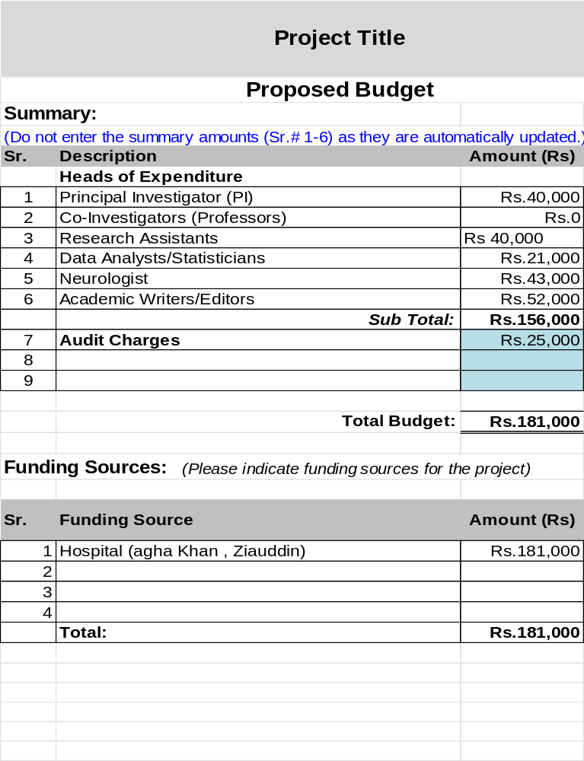

Business Canvas:

Business Canvas

Business Model Canvas |  | Designed for: | Designed by: | Date: | Version:
 |  | EEG analysis for neurologists. |  | 06.02.2024 | 1
Problem | Solution | Value Proposition | Customer Relationship | Customer Segments
A large number of individuals are affected by neurological disorders, which can be challenging and time-consuming to diagnose accurately due to the complexity of brain activity. Traditional diagnostic methods often require extensive time and expertise, leading to delays in treatment and increased healthcare costs. Moreover, while useful, existing technologies do not fully address the need for rapid and precise interpretation of EEG data, resulting in a gap in the efficient and effective diagnosis of neurological conditions. | To rectify this problem, we’ve proposed this project. We propose a CNN model utilizing Kullback-Leibler divergence to analyze EEG data efficiently. This model identifies distinctive brain activity patterns, enhancing the speed and accuracy of neurological disorder diagnoses. | Our system proposes a Convolutional Neural Network (CNN) enhanced by the Kullback-Leibler divergence to analyze EEG data efficiently. It rapidly identifies patterns indicative of neurological disorders, significantly reducing diagnostic times. Offering precise, real-time analysis enables neurologists to make informed treatment decisions quickly, improving patient care. The solution requires access to computing power and storage for handling complex datasets, ensuring comprehensive EEG data analysis. | The Mobile Application will be user-friendly for blind people. All blind people around the world can access this Mobile Application through the Google Play Store, which will be available free of cost. It will be easy to use, so new users will not have issues. | This EEG analysis tool is primarily designed for healthcare providers, specifically neurologists, who need advanced diagnostic capabilities to accurately and efficiently diagnose neurological disorders. Additionally, research institutions involved in neurological studies can benefit from the precise data analysis offered by our tool. Secondary users include medical students and academic professionals who require real-world applications of EEG data interpretation in their curriculum and research.
 | Development Resources |  | Channels
 | Python  Jupyter Notebook  Pytorch  Tenserflow  Keras  Keras CV  Pandas |  | 1. Google Play Store
Cost Structure |  | Revenue Streams
1. Technical Staff and Development Cost= PKR 80,000  2. Support Staff = PKR 70,000  3. Miscellaneous = PKR 5,000 |  | 1. Revenue generated from hospitals and clinics paying for the use of the software.

- Conclusion:

The project aims to develop and implement an optimized machine learning model, specifically a Convolutional Neural Network (CNN), to enhance the analysis of EEG data for the detection of harmful brain activities such as seizures. The scope includes acquiring EEG datasets from Kaggle, developing and training the CNN to identify and classify EEG patterns associated with neurological disturbances, and integrating this model into a user-friendly application for neurologists. The project will focus solely on EEG data and is specifically aimed at improving the speed and accuracy of neurological diagnostics. It excludes the analysis of non-EEG data, comprehensive coverage of all neurological conditions, real-time integration across all hospital systems, and the development of EEG hardware.

7.
References
[1]. Henry, J.C. Electroencephalography: Basic principles, clinical applications, and related fields. Neurology 2006, 67, 2092.

[2]. W. Zaremba, P. Kuman, A. Gramfort. And M. Blaschko, (2013).

[3]. M. H. Abdullah, J. M. Abdullah, and M. Z. Abdullah, “Seizure detection by means of hidden Markov model and stationary wavelet transform of electroencephalograph signals,” in Proceedings of the IEEE-EMBS International Conference on Biomedical and Health Informatics (BHI ’12), pp. 62–65, Hong Kong, January 2012.

[4]. M. Alamgir, M. Grosse-Wentrup, and Y. Altun. Multitask learning for brain-computer interfaces.
In International Conference on Artiﬁcial Intelligence and Statistics, pages 17–24, 2010

[5]. A. Andreev, A. Barachant, F. Lotte, and M. Congedo. Recreational applications in OpenViBE:
Brain invaders and use-the-force. In In ”Brain-Computer Interfaces 2: Technology and
Application”, M. Clerc, L. Bougrain, F. Lotte (Eds), Wiley-iSTE, pages 241–258, 2016
[6]. Borgomaneri, S.; Battaglia, S.; Garofalo, S.; Tortora, F.; Avenanti, A.; di Pellegrino, G. State-dependent TMS over prefrontal cortex disrupts fear-memory reconsolidation and prevents the return of fear. Curr. Biol. 2020, 30, 3672–3679.
[7]. Delimayanti, M.K.; Purnama, B.; Nguyen, N.G.; Faisal, M.R.; Mahmudah, K.R.; Indriani, F.; Kubo, M.; Satou, K. Classification of brainwaves for sleep stages by high-dimensional FFT features from EEG signals. Appl. Sci. 2020, 10, 1797
[8]. Kulkarni, N.; Bairagi, V. Extracting salient features for EEG-based diagnosis of Alzheimer’s disease using support vector machine classifier. IETE J. Res. 2017, 63, 11–22

[9]. Morabito, F.C.; Campolo, M.; Ieracitano, C.; Ebadi, J.M.; Bonanno, L.; Bramanti, A.; Desalvo, S.; Mammone, N.; Bramanti, P. Deep convolutional neural networks for classification of mild cognitive impaired and Alzheimer’s disease patients from scalp EEG recordings. 1-6

